Pixel Edit

Made by Alex Mollard

# Overview:

The aim of this application is to allow the user to create or edit already existing sprites.

I am aiming to allow the user to be able to even make gifs with overlay functionality and grid display.

# Context:

The problem with applications such as photoshop, paint and other image editing software such as gimp is they offer a minimal amount of pixel art support with none of them allowing you to create gifs without having to mess around with layers and other time-consuming gimmicks, my goal for my application is to allow the user to create smooth and detailed pixel animations with ease.

Goals: **Graphic user interface:**

**Create a productive and simple user interface so that the user does not have to undergo a learning curve and can just start creating amazing art from the moment they open the application.**

**Edit Image:**

**Allow the user to create new pixels or edit already existing ones on an image.**

**Grid:**

**Allow the user to display a grid overlay that will have customizable grid spacing and sizing to help line up pixels.**

**Drag and Drop:**

**Allow the user to be able to simply drop their art into the application instead of having to open a finder and selecting their art.**

**Gif Creator:**

**Allow the ability to create gifs from multiple images and can over lay the previous frame to help the user know what pixels to edit making allowing them to create gifs faster.**

**This feature will have a live preview of their gifs playing and a section of the application will display the frames of the current gif in descending frame order.**

**Cellular automata:**

**This will allow the user the ability to try simple artificial intelligence to improve their work. Examples of possible functions:**

* **Auto-Outline**

**Finds a pixel that is next to 2 of more empty pixels and makes pixel equal selected colour.**

* **Auto-Shade**

**Finds pixels to the direction selected from selected colour and darkens or brightens them.**

* **Auto-Delete Excessive Pixels**

**Finds pixels with selected colour and removes them if neighboring pixels with same colour is more selected amount.**

**Multi-User Edit:**

**Create the ability for the user to allow another user to edit their image as they work on it, this could allow the user to create more abstract artwork and will make the application more appealing to non-art people to use.**

# **Diagrams:**

**Main Mockup:**

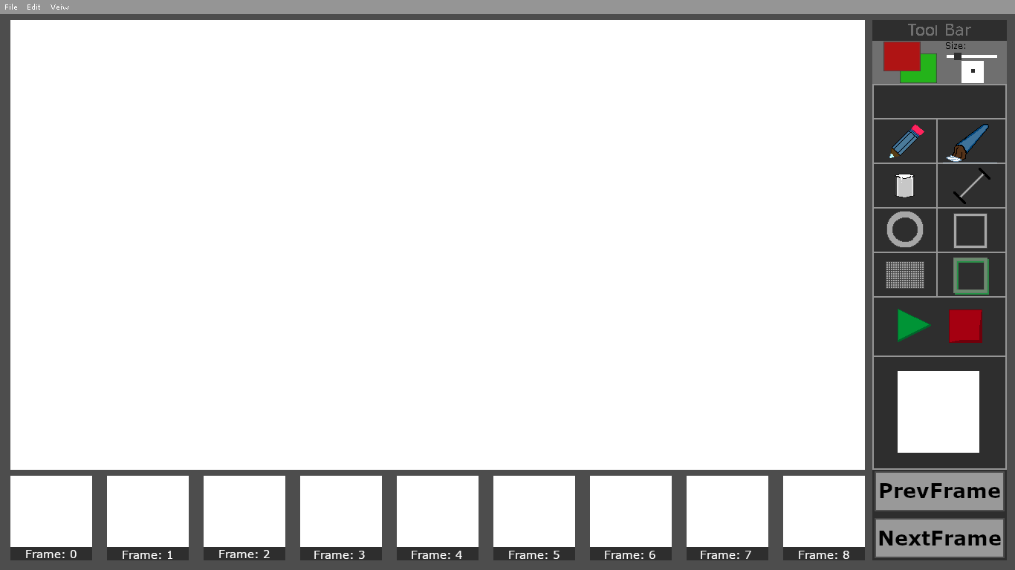

**Tool Bar**

**Editing Space**

**Gif Live View**

**Gif Frames**

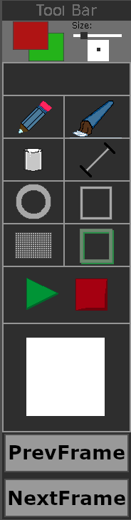**Tool Bar:**

**Gif Frames:**

